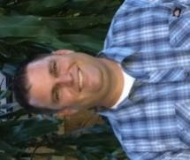

Overview

Cloud 9 Services, Inc.

1201
W Jackson St
reet
,

Orlando, Fl
orida

32805

P: (407) 864
-
8844

/
F: (407) 481
-
8850

Cwalker@cloud9services.com

CURTIS WALKER

General Manager

Mr. Walker has more than 20 years of Plumbing and Underground Utilities experience. He has participated in a variety of projects for state, county, municipal, and private agencies. His project management experience includes a wide range of projects, including lift stations, grease traps, storm pipe, sewer pipe, cured in place pipe, manholes, water pipe, video inspection, laser profiling, pipe cleaning, hydro excavation and grouting.
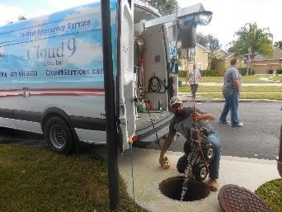
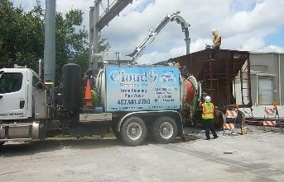
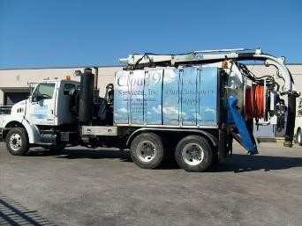
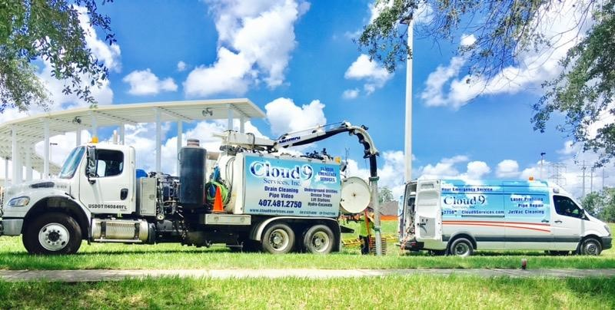
Mr. Walker has a detailed understanding of the criteria that makes projects a success and currently manages the Orlando office’s projects and pursuits. He currently holds a Florida Plumbing and Underground Contractor's license, Pipeline Assessment Certification, Advance MOT certification and confined space entry certification. Mr. Walker has a detailed understanding of plumbing and all underground work that will make a successful project.

Project Work Experience

➢

SGL I
-
4
project
-

Sewer and Storm Structure Grouting, lining,
cleaning and video inspection

➢

C
ity of Orlando

–

Lift
Station
, Sanitary

Sewer and Storm Structure
Grouting,
repairs,
lining, cleaning and video inspection

➢

S
ema Construction
, Inc.,

Turnpike S
R
-
417
and S
R
-
408
Projects

-

Sewer and Storm Structure Grouting, lining, cleaning and video
inspection

➢

Hubbard Construction
,

Bu
e
na Vista
Drive

project

-

Sewer and
Storm Structure Grouting, lining, cleaning and video inspection

➢

Middlesex Construction
,

OIA project
-

Se
wer and Storm Structure
Grouting, lining, cleaning and video inspection

➢

Brasfield and Gorrie

Construction Engineering,

Florida Hospital
Project
-

Sewer and Storm Structure Grouting, lining, cleaning
and video inspection

